Extinct Florissant Valley Animals
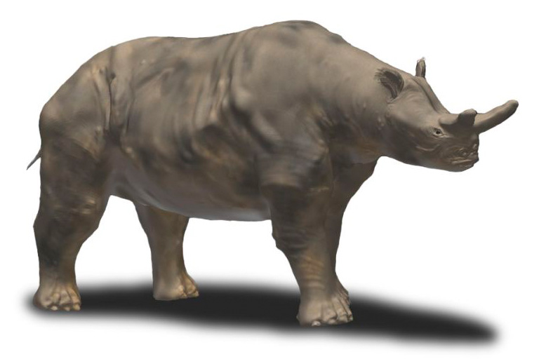 Nobu Tamura
Brontothere: Lived in warm, temperate forests and open woodlands 37 million to 34 million years ago. It was an herbivore that grew to be up to 8 feet tall at the shoulder and 14 feet long. This makes it the largest animal found at Florissant Fossil Beds! It is known for its sling-shot shaped horn on the nose. Its living relatives include the horse, rhinoceros, and tapir.
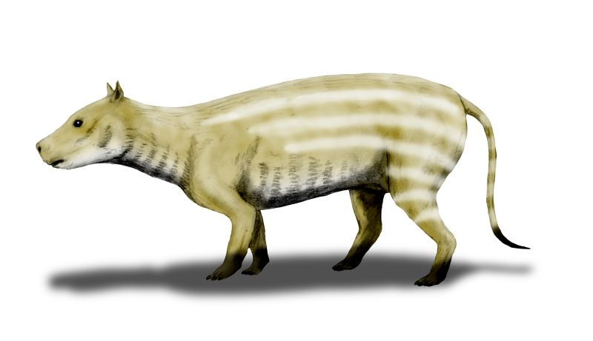 Nobu Tamura
Oreodont: A sheep-like herbivore that lived in woodlands, forests, and grasslands from 48 million to 7 million years ago. It was about the size of a sheep and had a long tail for its body size. It has no living relatives today but paleontologists think it might have lived in herds.
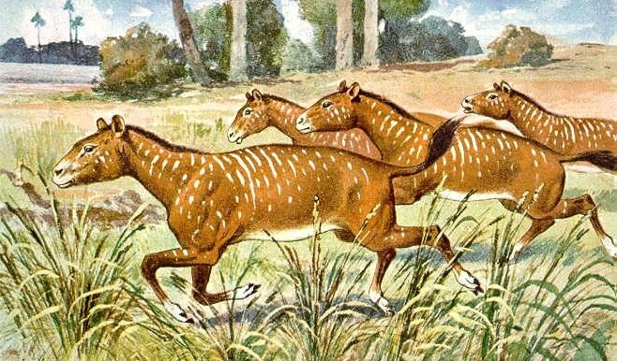 Heinrich Harder (1858-1935)
Mesohippus: A small three toed horse that lived in the lakeside forest of Florissant Valley and open woodlands 40 million to 28 million years ago. It was an herbivore that ate leaves and twigs. Mesohippus only grew to be about 2 feet tall at the shoulder. Paleontologists have found that it had a large brain for its size.
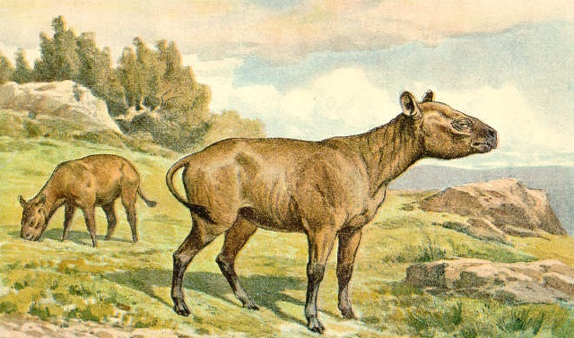 Heinrich Harder (1858-1935)
Hyracodon: A small rhinoceros that lived in forests and wooded steppes 34 million to 31 million years ago. It was a herbivore like its living relatives, the modern rhinoceros. Paleontologists have called it the “running rhino” for its long legs.

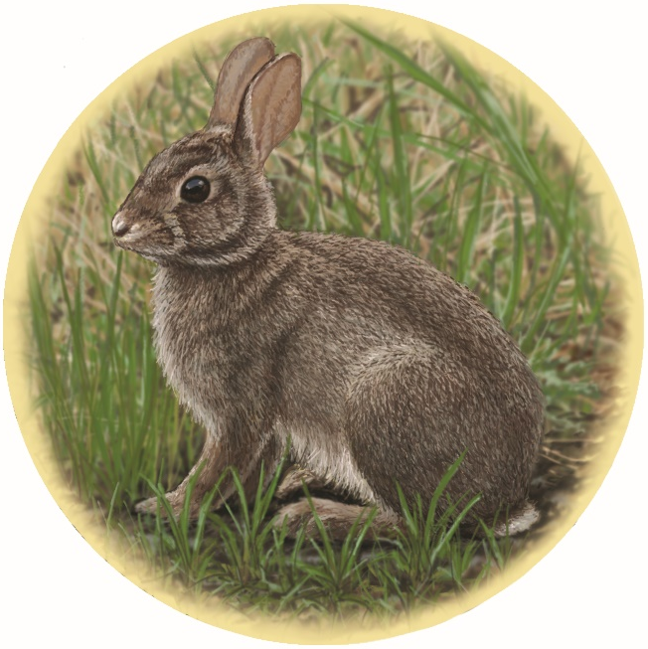
Megalagus brachydon: An ancient rabbit from 40 million to 23 million years ago in forests and grasslands. It was a herbivore related to modern rabbits. It grew to be about 25 centimeters long with short back legs for a rabbit. Because of its short back legs, it likely ran rather than hopping.
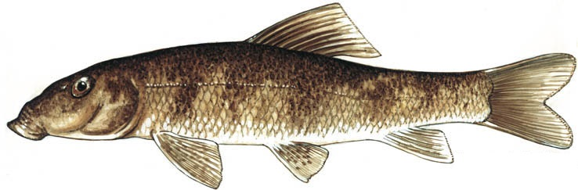
Amyzon sp.: Sucker fish that lived from the Eocene to the Oligocene. This was the most diverse group of fish from Florissant. They lived in lakes and streams feeding on algae and insect larvae. They grew up to 2 to 3 feet long and had pursed lips.
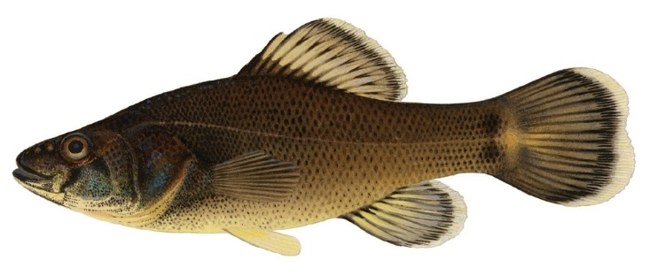
Tricophanes foliarum: Pirate perch lived in lakes and ponds in the Eocene. This fish grew to be about 8 to 10 centimeters long. It ate insects and was eaten by larger bowfin fish. It was related to Aphredoderus, a modern pirate perch.
Edgar R. Waite
Bowfin: One of the larger fish that once lived in Ancient Lake Florissant. This is a bony fish related to gar fish. Sometimes living bowfin fish, still living in freshwaters today, are called “primitive” fish because they have kept a number of traits from their early relatives.
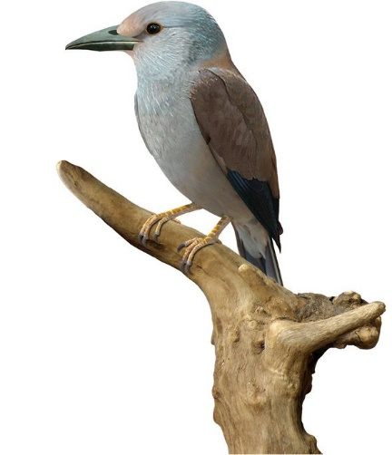
Palaeospiza bella (Roller Bird): A bird in the Eocene that migrated every year preferring warm climates. The diet of this bird included insects, spiders, and small vertebrates. It grew to be around 10 to 11 inches long. It is related to modern roller birds living in Africa, Asia, and Europe.

